**JobsRevenue**

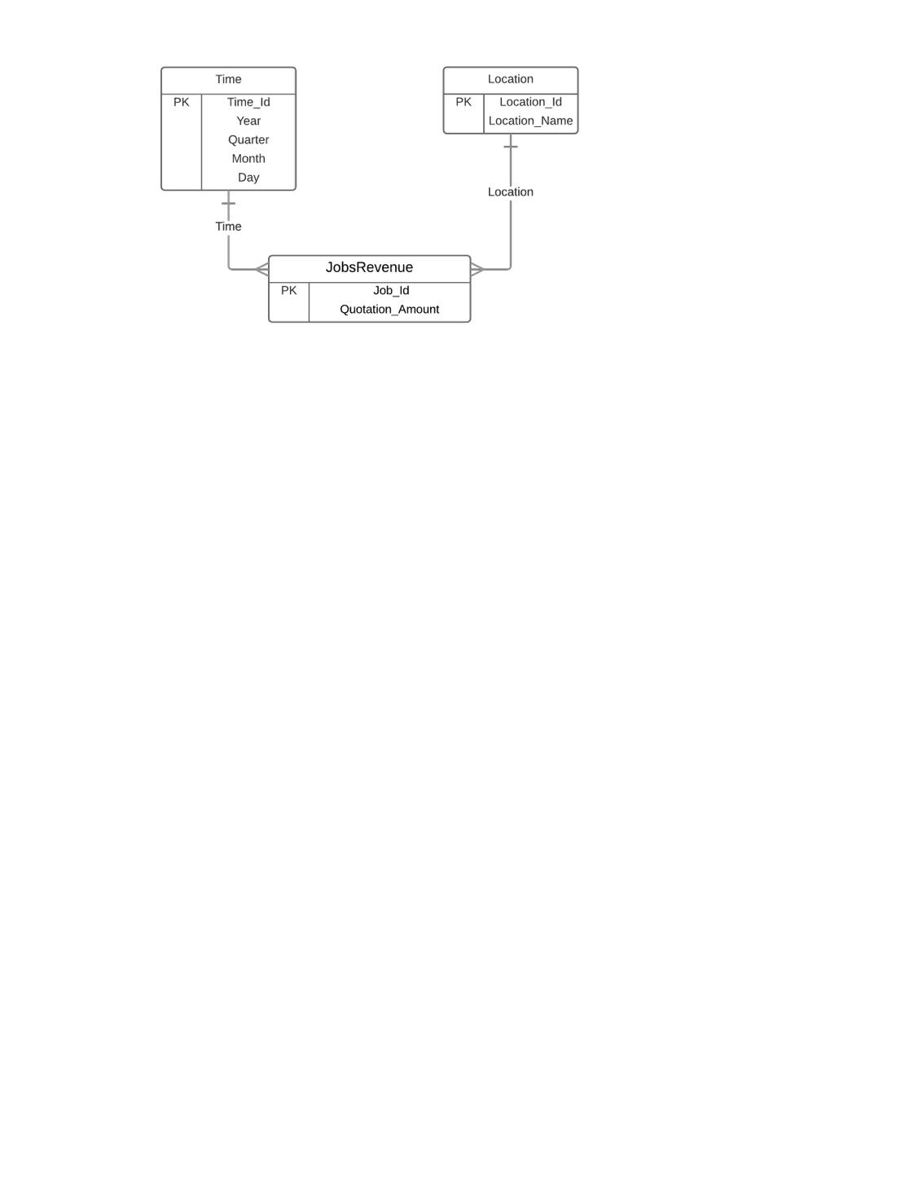

**Leads2Jobs**

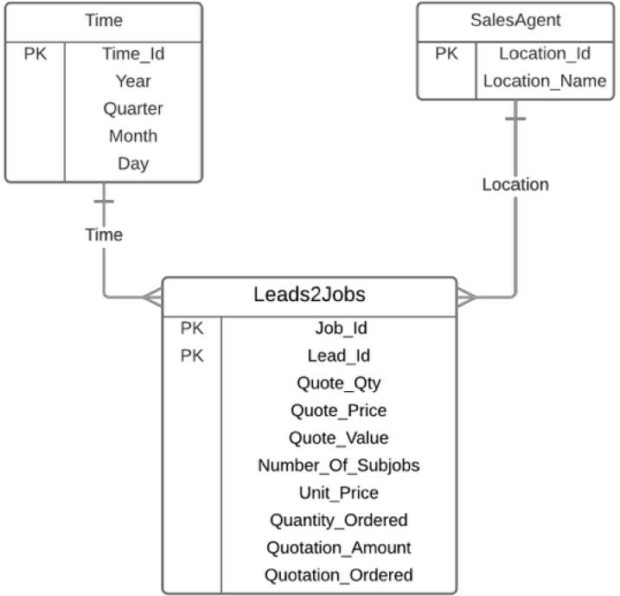

**Jobs2SubJobs2Shipments**

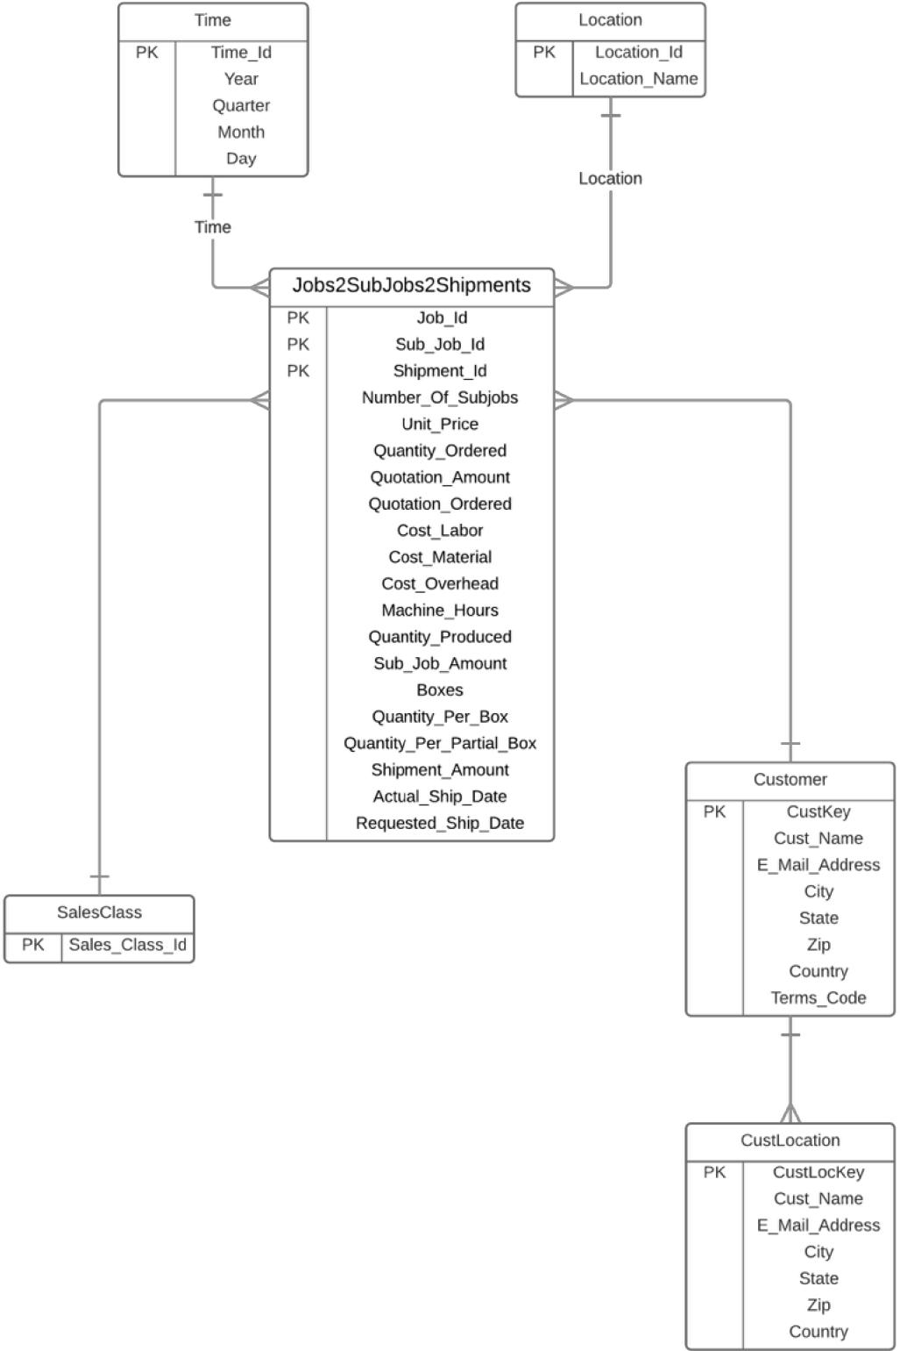

**Invoice**

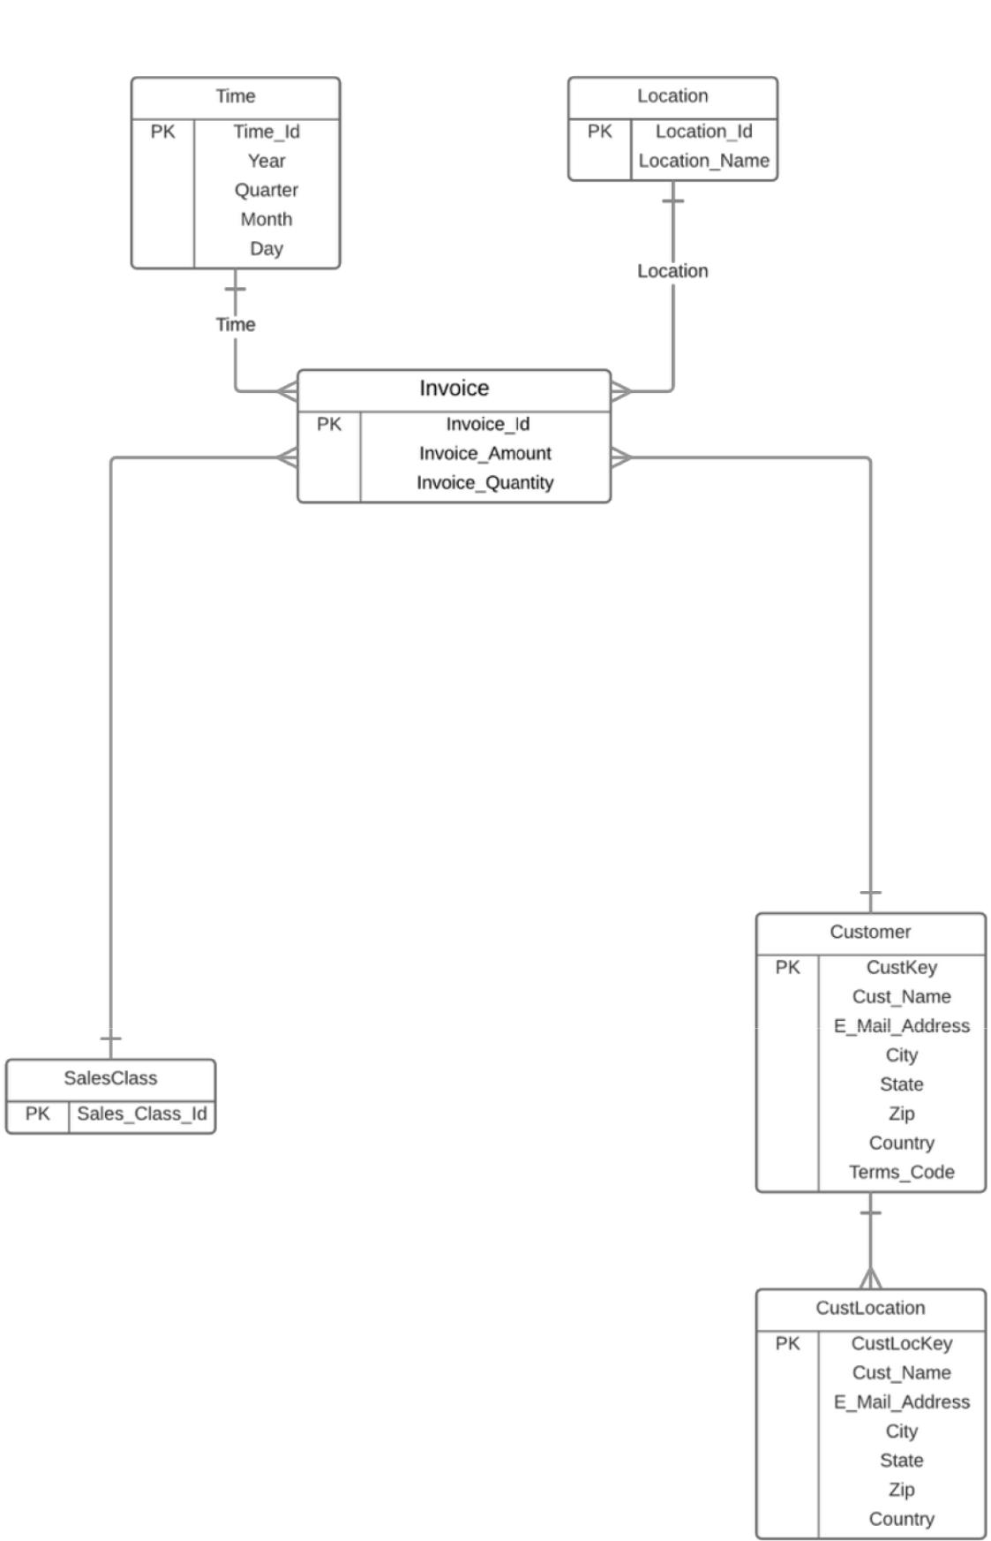

**Jobs2SubJobs2Invoices**

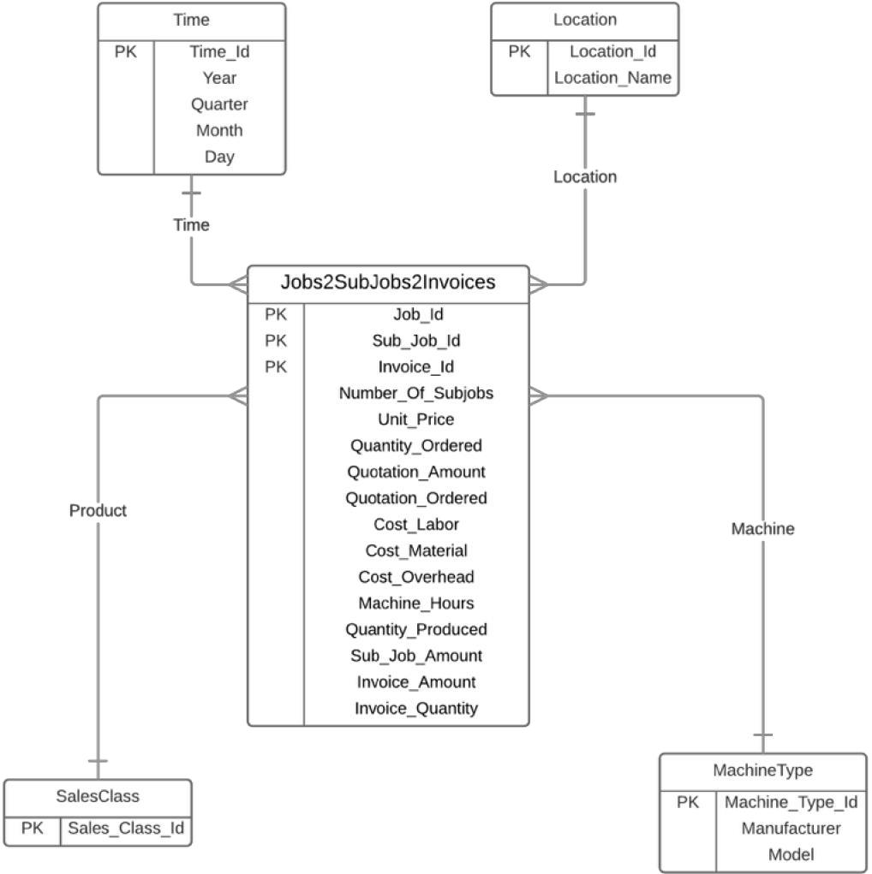

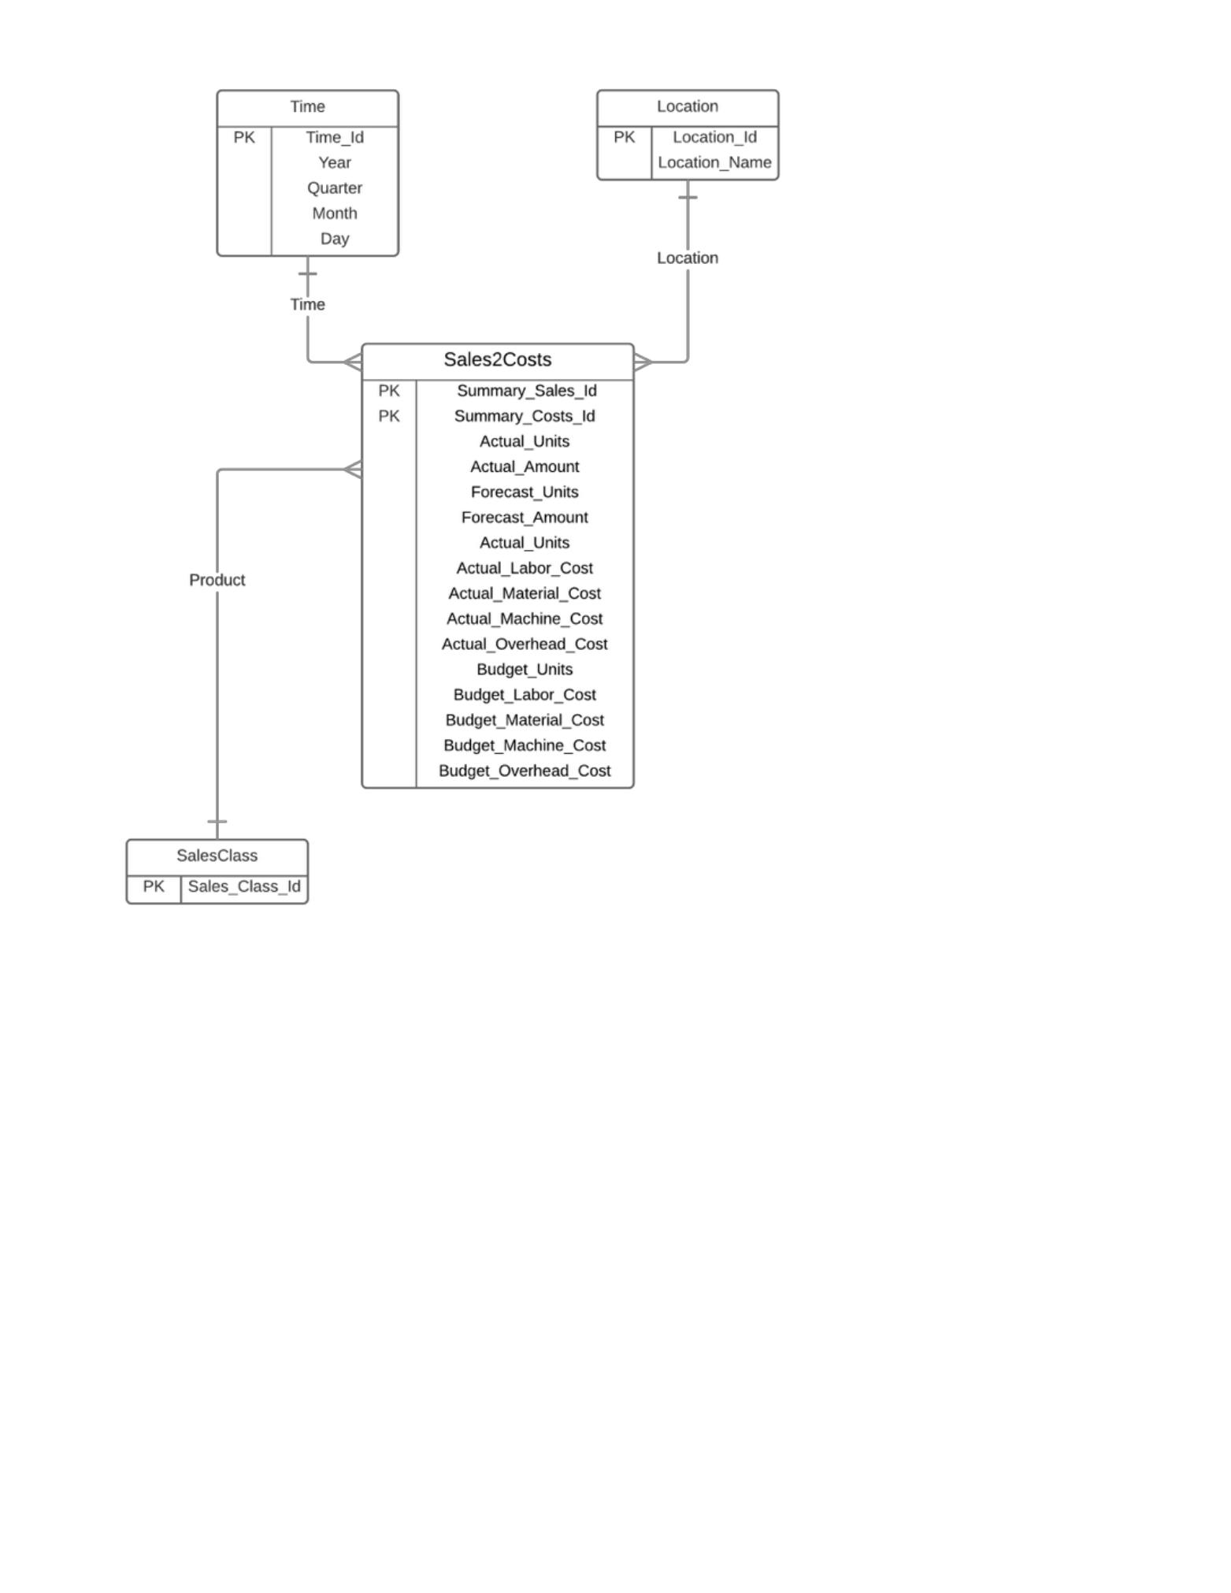**Sales2Costs**

|  |  |  |  |
| --- | --- | --- | --- |
| **Schema type** | **Dimension tables** | **Fact table** | **Comments** |
|  |  |  |  |
| Constellation | - | - |  |
|  |  |  |  |
|  | Time | JobsRevenue |  |
|  |  |  |  |
|  | Location | Leads2Jobs |  |
|  |  |  |  |
|  | SalesAgent | Jobs2SubJobs2Shipments |  |
|  |  |  |  |
|  | Customer | Invoice |  |
|  |  |  |  |
|  | SalesClass | Jobs2SubJobs2Invoices |  |
|  |  |  |  |
|  | MachineType | Sales2Costs |  |
|  |  |  |  |